**Pinning Hope**

**Pinterest, the Queer Archive and Obama's Evolution on Same-Sex Marriage**

Throughout its rhetorical life, the Obama Hope image, originally designed by Shepard Fairey, has become embroiled in many diverse social issues and campaigns since 2008. From advocating for the environment to protesting against the escalation of war to fighting against oppressive regimes, Obama Hope has appeared in many political and social battles across the world. In the United States, one of the important social issues in which the Obama Hope image became articulated was the battle for the legalization of same-sex marriage. In 2008, Proposition 8 (a piece of California legislation that strictly defined marriage as a union between one man and one woman) was on the ballot and passed the same year Barack Obama was elected. Although he disagreed with the bill, Obama remained steadfast in his support of civil unions over same-sex marriage throughout his first term as president. Later, Obama’s stance on same-sex marriage “evolved,” and he eventually came out publicly supporting the legalization of same-sex marriage. This public move, combined with the overturning of Don't Ask Don't Tell, and the Defense of Marriage Act during his tenure as president, made Obama a hero in many eyes of mainstream gay rights activists. The Obama Hope image, which was initially employed to pressure Obama to support gay rights in the early days of Obama’s campaign and presidency, was later used to celebrate such evolution in Obama’s stance on the issue.

This chapter traces and analyzes the discourses associated with same-sex marriage throughout Obama’s campaign and presidency as well as the “evolution” of the image in relation to Obama’s changing stance. To not only facilitate such tracing and analysis but also document this important history, I curated a queer digital archive titled “The Evolution of Obama Pride,” using the popular image saving software, Pinterest. Regarding methodology, this chapter draws on queer theory and rhetorical theory to explore archival methods and positive potentials of carrying out such queer, digital, archival work for digital visual studies. I argue that Pinterest can be a valuable tool for queer individuals and communities to not only access historical archival materials but also curate and circulate visual artifacts and aid queer communities in achieving a sense of belonging. For scholars, archives constructed as Pinterest boards can also help identify patterns in sets of data that lead to productive rhetorical insights about the function of visual icons in social movements such as fight for same sex marriage. However, through a rhetorical critique of the archive as a whole, I also identify how queer archival practices can often perpetuate normative ideologies that academics often wish to work against. As we continue to play with digital visual archival studies, then, I ultimately argue that researchers must pay close attention to *rhetorical undercuts--* the ways that, in this case, our own archives function as *impure platforms* that often undermine emancipatory ambitions even as they simultaneously harness transformative potential.

**Obama, Hope, and Same-Sex Marriage**

Issues of difference have intimately been connected with Obama since the beginning of his presidential campaign. The narrative constructed around Obama’s life during his 2008 campaign initially emphasized that he was unlike previous candidates: “African father from Kenya, white mother from Kansas, raised in Indonesia and Hawaii on modest incomes and educational scholarships…Obama marked the ways his racial class and geographic origins made him unusual (queer) presidential material” (Rohrer 110). Despite Obama's race, class, and geography signaling that difference can be a hope for a brighter future, his stance on same-sex marriage remained relatively conservative. In 2004, for instance, he made a statement defining marriage as between a man and a woman and claimed that he did not see same-sex marriage as a civil right even though he had long favored civil unions (Dwyer). Later, he publicly opposed Proposition 8—a state-level ban on same-sex marriage. Obama found himself in a precarious political position in regard to Prop 8, as his personal beliefs, potential alienation of religious supporters, and his beliefs about the role of the constitution in granting or restricting rights to Americans intersected. In a 2008 interview with MTV, Obama clarified his conflicting public stances on state constitutional amendments defining marriage stating the following:

I’ve stated my opposition to this. I think [Prop 8 is] unnecessary. I believe marriage is between a man and a woman. I am not in favor of gay marriage. But when you start playing around with constitutions, just to prohibit somebody who cares about another person, it just seems to me that’s not what America’s about. Usually, our constitutions expand liberties, they don’t contract them (Belonsky).

The tensions present in Obama’s stance on same-sex marriage, in conjunction with Prop 8 appearing on the same ballot as Obama’s presidential bid, kept same-sex marriage in the spotlight during much of his campaign (Wildermuth).

In light of Obama’s stance toward gay marriage, the Obama Hope image was invoked in the fight against Prop 8 in various ways as well as in critiques of Obama’s conservative position. Protest signs, for instance, with the word "Hope" replaced with the words "Fail" and "Fraud" made appearances at rallies for Prop 8 in Los Angeles and other cities. In addition, *The Advocate* (an LGBT publication) called out Obama for his lack of support in August of 2009. According to *The Advocate’s* editor-in-chief, Jon Barrett, the cover image and accompanying article were meant to capture the growing frustration felt by gay voters who believed they were not seeing the payoffs, such as repealing the Defense of Marriage Act and Don’t Ask, Don’t Tell, promised during the election (Mirchandani). The issue’s cover story captured this disappointment and concern:

“…during his first months in office, while he [Obama] worked with Congress on the economic stimulus package and the wars, and laid `groundwork for legislation to protect the environment and reform health care, we were on our best behavior, waiting for him to reveal his plans to keep his promises to us…. Unquestionably, a lot of us have been patient about progress on gay civil rights during these first months because we are still traumatized by the culture wars. We fought hard to get this president and Congress elected, and we don’t want to mess up their chance to fix what’s broken. But the window of opportunity for bold action on gay rights at the federal level grows narrower every day. (Gross).

To advertise this cover story*, The Advocate* cover featured the Obama Hope image illustrated in lavenders and pinks. The official Obama logo on his right lapel was replaced with an upside-down pink triangle. The use of pink and inclusion of the triangle—a symbol that had become a rallying cry for the LGB community during the AIDS crisis—and the use of lavender which is often used to denote gay and lesbian communities (Betty Friedan infamously referred to lesbians as the lavender menace and claimed they hampered the feminist movement, as well as, the mass firing of gay and lesbian government employees during the 1930s and 40s being referred to as the Lavender Scare) make direct ties between Obama and less celebratory moments in LGB history. The word “Hope” was replaced with “Nope?”, most likely reflecting Obama’s unkept promises.

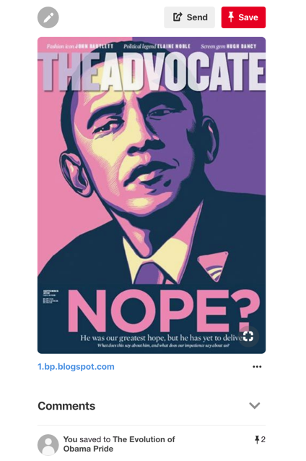

**Figure 1: Screen Shot of *The Advocate* Cover Pin.**

In late 2010, as Obama began to hint at shifts in his stance on same-sex marriage, so too did the Obama Hope image shift in form and substance. Such a change started slowly, with Obama simply and publicly stating that his feelings were evolving, even though he still favored civil unions rather than marriage for same-sex couples (Dwyer). In a press conference given at the White House, Obama addressed his continuing evolution on his stance in regard to same-sex marriage:

At this point, what I’ve said is, is that my baseline is a strong civil union that provides them the protections and the legal rights that married couples have. And I think — and I think that’s the right thing to do. But I recognize that, from their perspective, it is not enough. And I think this is something that we’re going to continue to debate, and I personally am going to continue to wrestle with going forward” (Shackelford & Lebling).

In December of the same year, Obama signed the repeal of Don’t Ask, Don’t Tell (which prevented gay men and lesbians from openly serving in the military), the first step of an institutional tie between Obama and gay rights. Then, in May of 2012, the year of Obama’s second presidential campaign and the year that support for same-sex marriage became the majority opinion, Obama officially announced his support for gay marriage. In an ABC News interview, Obama states “At a certain point, I've just concluded that—for me personally, it is important for me to go ahead and affirm that—I think same-sex couples should be able to get married” (Steinmetz). With Obama becoming the first US President ever publically to endorse same-sex marriage, *Newsweek* quickly declared Obama “the first gay president” (Schwarz). The printed cover featured a headshot of Obama with a rainbow-colored halo, but one of the first designs to be considered for the cover was the Obama Hope image painted in a rainbow of color (Stableford).

In 2015, we witness even more changes in the Obama Hope image after the US Supreme Court overturned the Defense of Marriage Act (DOMA) in June of that year, making same-sex marriage legal in all 50 states. With his official statement of support for the Supreme Court’s ruling, Obama’s “evolution" regarding same-sex marriage, in conjunction with the overturning of Don't Ask, Don't Tell and DOMA, had come full circle. In fact, in many people's eyes, Obama had become a gay rights pioneer. For example, The Human Rights Campaign—the US's largest LGBTQ civil rights organization—published a tribute to Obama’s work in regard to LGBTQ rights and visuality, arguing that “Barack Obama’s legacy of achievement for LGBTQ people is unmatched by any president in American history.” The tribute cites actions taken by Obama such as naming Stonewall as the first LGBTQ national monument and his executive policies as evidence of Obama’s support for LGBTQ equality (Miller).

The Obama Hope imagery, which had initially been used to call out and question Obama and then slowly evolved to signify him an ally, took on an even more celebratory tone. Soon after DOMA was overturned, the Obama Hope image appeared against rainbow backgrounds, with the word “Hope” replaced with words such as “Pride” and “Evolved.” Versions of the original image with the words “Change” or “Victory” were also featured in articles referencing the “victories” of the LGB community. Such changes in Obama's stance toward same-sex marriage and the parallel transformation of Obama Hope are an integral part of LGBT history in the United States that needs to be documented and archived.

**Pinterest as a Queer Digital Archive**

As scholars interested in LGBT history continue to engage with digital visual studies, it will be important to think more deeply about how to use digital visual technologies to support archival work deftly. As Charles Morris argues, archives play an important role for gay communities in that, operating outside of ideology and politics, archives perform rhetorical work. Archives are essential not only for the role that they play in passing down knowledge from generation to generation but also for the work they do in making LGB individuals and experiences knowable (Morris & Rawson). Unfortunately, the archival holdings that are queer in nature are often stored in archives that deflect or discourage queer inquiry. Because so much of LGBTQ history is stored in what might be considered “straight” institutions such as LGBTQ special collections housed in university libraries, or as illustrated by Morris government institutions such as the FBI, it is often necessary for scholars to “queer the archive” (Morris; Rawson). In fact, Morris argues that due to the silencing of queer experiences and benevolence of academic colleagues, scholars of queer rhetoric must become the “deftest of archivist-rhetors or archival queers” (147). He identifies this work as a form of academic activist labor that serves the discipline on three levels. First, it makes room for rhetorical scholarship of sexuality to be taken seriously as a main influence of rhetorical culture, not just an aspect of context or character. Second, it helps the history of LGBT discourse become more widely acknowledged, taught and written about. And third, the circulation of historical queer discourses pushes and stretches disciplinary boundaries in significant ways. In light of such benefits, Morris calls for more scholars to undertake queer archival work.

Digital technologies, the Internet, and social media, in particular, have created an opportunity to increase the circulation and distribution of queer discourses and histories. Also, as evident in this project, they afford new ways to archive, curate, and critique circulating discourses. Alexander and Rhodes, in fact, see online archives and digital curation as powerful tools for enacting queer movement and networks. They state that digital technologies are invaluable to queer archival scholars because they both make available queer voices and experiences as well as facilitate the collection, curation, and circulation of queer artifacts. Digital curation is a catch-all phrase that refers to the use of digital technologies and multiple modes of online spaces to select, organize, and present material artifacts. While traditional institutions are still responsible for much historical curation, in our current digital reality, curation need not be not limited to museum and art professionals. The Internet and social media tools have made it possible for everyday citizens and amateur collectors to collect, exhibit, and curate images and texts in public spaces available to mass audiences. Queer archivists can take advantage of such tools to not only collect and curate these images but also to make images more accessible to the queer community. As Rawson has argued, physical archives can pose a challenge to queer bodies because they may not feel welcomed into material spaces. Digital technologies and platforms can provide resources that allow queer bodies to more easily and comfortably access their histories and communities.[1]

Pinterest, a digital bookmarking tool that allows users to collect and share photos and websites on themed “boards,” proves to be an especially useful tool for not only generating digital archives but, in Morris’ terms, queering them. Pinterest, as advertised, is a visual bookmarking tool that can help “you discover and save creative ideas” (About Pinterest). For our purposes here, it also “serves as an infrastructure for repository building that supports a wide range of activities including: discovery, collecting, collaborating and publishing” (Zarro et al. 650). The site is particularly relevant to digital visual studies in that its infrastructure privileges the visual not only concerning content but also search techniques. "Pins" are uploaded image files collected from various websites and uploaded onto an individual's Pinterest board. When a user creates a board, typically defined by a theme, and adds pins, the user has the option of writing brief captions and adding URL links. Such links create the option for a visitor to leave that Pinterest board and visit the site where the user found the image to learn more about the context in which that image originated or was reproduced and/or redistributed. In addition to pinning offsite information, users can search for pins that have already been added to the Pinterest universe and “repin" them to their own boards to enhance their own collection.

While Pinterest originated as a way for everyday citizens to collect and share images and to build their own collections, Pinterest can be conceptualized as a means of productive archival research for both everyday citizens and scholars. “While pinners may not call themselves archivists,” Almjed argues, “they are indeed always curating personal identities and exhibits for themselves and others” (10). Such curation actions, I would add, can also be viewed as rhetorical attempts to build personal archives that both represent and construct collective identities, especially in that such actions of visual display entail intentional and deliberate selection and omission. Prelli’s work with rhetorics of display helps elucidate how visual displays on Pinterest do such crucial work in regard to highlighting and revealing and promoting or limiting meaning-making possibilities. As Prelli explains, “whatever is revealed through display simultaneously conceals alternative possibilities;” whatever a display makes visible, in other words, is “the culmination of selective processes that constrain the range of possible meanings to those who encounter them” (1-2). Prelli also notes that visual artifacts and the names, labels, and narratives attached to them direct our attention in specific ways and constrain our responses to them. In addition, the places in which visual artifacts are housed, whether physical or digital, are rhetorically disposed in their design so that their arrangement works to dispose certain attitudes, feelings, and behaviors of those who visit or construct such places. Furthermore, visual displays are always demonstrations, rhetorical performances that not only highlight certain (individual and collective) convictions, identifications, and conceptions of self but also, in Richard Weaver’s terms, “embody an order of desire” in that they “are laced with assumptions about what is or is not desirable or to be valued, about what is and is not praiseworthy, about what ought and ought not to be (qtd. in Prelli 16).

When pinners chose to include or omit visual artifacts on their Pinterest boards, they are making claims about who and what they value, and in many cases, such as my Pinterest board, they are indicating a sense of belonging to communities such as the LGBTQ community. As Ott, Aoki, and Dickinson (2011) point out, ways of looking are never neutral and what is left out of a visual display is just as important as what is made present. Such omission is crucial for the pinner or archivist who wants to not only present a particular version of themselves to the world or make visible communities they align with but also construct what kinds of histories they want to tell. Who is included or left out of archival records determines who is or isn’t remembered. Traditionally, materials and artifacts that have been preserved in archives tend to omit or silence those who hold less privilege in society such as LGBTQ populations and people of color (Jules). The erasure of entire communities from the historic record results in what media scholars have coined *symbolic annihilation,* a phenomenon that most commonly occurs as marginalized groups and individuals are ignored or misrepresented in mainstream media texts. *Symbolic annihilation* within historical archives can result in marginalized groups feeling alienated and isolated from mainstream culture. When marginalized groups see themselves represented in historical archives (institutional or personal), on the other hand, they experience what Caswell, Cifor, and Ramiree have termed *representational belonging*—an affective reaction to seeing themselves and communities represented in complex and nuanced ways. Pinterest boards are one way to facilitate *representational belonging,* community visibility and identity legitimization as well as foster an affective sense of inclusion and belonging.

Such archival and rhetorical work on Pinterest, of course, is not without problems.

Several scholars have noted that Pinterest is heavily skewed towards women and reproduces normative and hegemonic notions of femininity and heteronormativity. The platform encourages users to participate in normative ideologies surrounding gender and sexuality through the collection of images related to normative notions of femininity such as fantasy weddings, dieting, interior decorating, and parenting (Almjed). Pinterest also feeds America’s obsession with consumption (Vetter). This is especially the case in that soon after its development, businesses realized the selling potential of Pinterest and began creating their own boards featuring their own products, essentially placing items that were explicitly for sale into the Pinterest universe. Pinterest also recently introduced “buyable pins,” a feature that allows users to buy products directly from the Pinterest interface. Such commercialization of the Pinterest universe creates a discursive link between heterosexual and normative expressions of consumer behavior that must be acknowledged (Almjed; Vetter).

Despite Pinterest’s normative leanings, however, users are starting to evolve and create boards and repositories for purposes other than serving consumerist agendas. According to Zarra et al., “there is [also] a growing number of people who build repositories for purposes other than showcasing beautiful and visually interesting imagery” (656). Such uses include academic and activist endeavors that often question and critique the normative assumptions that have come to construct the Pinterest universe. For example, Jen Almjeld speaks about her personal and academic uses of Pinterest that both help her explore how Pinterest helps to construct girlhood identities and experiences socially. Almjeld created publicly accessible boards related to things such as recipes and crafts. In creating such “domestic” related boards, Almjeld could be seen as upholding normative gender assumptions and Pinterest behavior, but she remains self-reflective in her engagement with the site stating, “as an adult and academic I am trained to critique, question, and in some cases resist the ways the Pinterest interface and community seem to encourage me to act” (11). Thus, Almjeld also created a secret board (a feature that allows users to create collections that cannot be accessed by other users) where she collects things related to her research that she does not find appropriate for her online Pinterest persona.

Almjeld is not the only scholar who is questioning and engaging with Pinterest in ways that resist and challenge the interface. Matthew Vetter critiques the heteronormative and consumerist nature of the Pinterest interface and as an academic experiment “queers the tech” by pinning images that resist consumerism and heteronormativity. Vetter’s project thus simultaneously acknowledges the ideological and political rhetorical agenda of Pinterest *and* uses the interface to resist these very ideologies. Through such double play, Vetter ultimately concludes that this misappropriation of the interface is a productive endeavor. Not only does Vetter introduce subversive content into the Pinterest universe, the interface she creates now works for academic projects. Vetter’s academic activism could potentially be seen as a creation of a queer anti-consumerist archive hosted on Pinterest.

Despite its gender normative and consumerist agendas, then, Almjeld and Vetter show us that Pinterest can be a useful academic tool for digital visual studies when engaging with queer and LGBT discourses. Such a clash of Pinterest's normative uses and queer resistance is very much in line with Halberstam’s concept of queer methodology.

A queer methodology, in a way, is a scavenger methodology that uses different methods to collect and produce information on subjects who have been deliberately or accidentally excluded from traditional studies of human behavior. The queer methodology attempts to combine methods that are often cast at odds with each other, and it refuses the academic compulsion toward disciplinary coherence (13).

Indeed, as this very project makes clear, queer digital archiving may ultimately prove to be a messy affair. However, despite such messiness and contradictions, we will see, when it comes to producing “The Evolution of Obama Pride” archive, Pinterest’s interface and boards can indeed become a productive digital research tool for collecting and analyzing queer discourses. As such, I move next to show through a description of my own archival construction process how we might cultivate productive queer archival research for doing digital visual studies.

**Pinning the Rainbow**

In order to examine the parallel evolution of Obama Hope and Obama’s stance on same-sex marriage, I used Pinterest to collect, exhibit, and curate Obama Hope images related directly to same-sex marriage and LGBT rights. The board began on my personal account and appeared alongside my very normative boards which include recipes, hairstyles, and cute animals. However, to expand Pinterest's interface beyond consumer and aesthetic purposes and instead employ it for activist and academic means,I created a new account dedicated to this project and moved all the pins to a new board that can be accessed [here](https://www.pinterest.com/pinterest_archi/obama-hope-evolution-of-same-sex-marriage/). After the board was set up, I collected images in several ways. First, I installed the Pinterest plug in my browser, which allowed me to pin images quickly and efficiently from any outside site. I then conducted searches for images related to Obama Hope and same-sex marriage on several sites including Google Image, Flicker, and Deviant Art. I also internally searched Pinterest for images that had already been pinned. One drawback to using Pinterest to archive images is that several images on Flicker were set to prevent sharing, which meant that the image was "unpinnable" and could not be included in the archive. One way around this would be to screenshot the image and upload that file onto the Pinterest board, but I ultimately decided against this practice, since sharing and privacy settings are determined by the person (presumably the creator) who posted the image. My Pinterest board is thus limited in its collection due to Internet privacy issues.

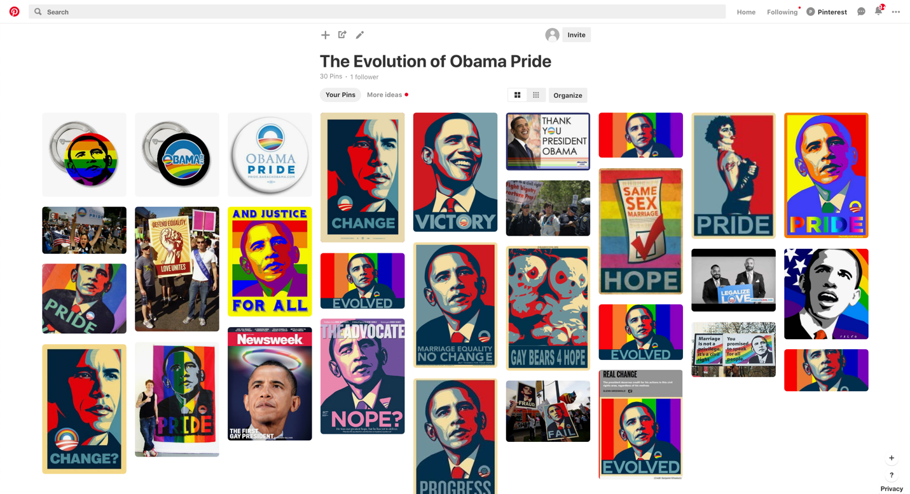

**Figure 2: Screen shot of “The Evolution of Obama Pride” Pinterest Board.**

Overall, however, Pinterest has several advantages for curating a digital collection of Obama Hope images related to same-sex marriage. First, the “Pinning” tool downloaded on one’s browser makes the process of collecting images fast and efficient. Second, in line with a queer archival agenda, hosting my archive on a public Pinterest board helps to propel the images into public circulation as well as potentially subvert the normative assumptions about how Pinterest should or shouldn’t be used. Pinterest especially makes visible how everyday citizens can use this platform to contribute to LGBTQ history. Third, the interface of Pinterest boards, which display visual artifacts in rows with little to no written commentary, affords easy contrast and comparison so that trends, patterns, and anomalies can be noticed and assist rhetorical analysis. For instance, the images in “The Evolution of Obama Pride” archive were specifically selected to reflect the evolution of Obama’s stance on same-sex marriage and the public response to this shifting position. In analyzing this selection of images on “The Evolution of Obama Pride” Pinterest board, one pattern that emerges is the explicit use of rainbow and other gay icons to both call out Obama's lack of support for same-sex marriage, as well as celebrate when his stance evolved. A rhetorical analysis of the rainbows in and across these documents complicates our understanding of how allies come to be represented and how straight people become appealed to the fight for same sex marriage.

The rainbow has a long history as a symbol used to identify and unite the LGBTQ community. The flag was designed by artist and Vietnam army vet Gilbert Baker at the request of Harvey Milk, who wanted the flag for the 1975 San Francisco Gay Pride Parade. In an interview, Baker stated that he wanted a symbol that would symbolize hope and convey a positive message for the community, rather than symbols of tragedy such as the pink triangle which marked gay men during the Holocaust (Morgan). In the years since its creation, the rainbow flag has become synonymous with the gay community, taking on iconic status. While the image has a rich history of being evoked by the LGB community, in recent years it has also become a marker of allyship. Organizations, business, and public figures who are not explicitly LGB invoke the rainbow to demonstrate that they support LGB causes and individuals. Examples of this include rainbow flag stickers on the windows of businesses indicating they welcome LGB patrons as well as *Imagine Dragons* lead singer Dan Reynolds draping a rainbow flag over his shoulders during a performance as a sign of solidarity and support for the LGBT community, despite identifying straight himself.

The Obama Hope artifacts using rainbow imagery that originated during Obama’s first campaign and his first years of presidency have a distinctly different flavor and are overwhelmingly critical of Obama and his lack of action in regard to same-sex marriage. As discussed in an earlier section, Obama Hope surfaced at many protests fighting for same-sex marriage. For example, at a New York rally opposing the California ban on same-sex marriage, signs featured a black and white image of Obama Hope on a rainbow background with the words, "Marriage is not a Privilege, It's a Civil Right"—most likely referring to Obama stating in an interview that "I don't think marriage is a civil right"—and “You Promised to Speak for All People…” referencing the expectations that Obama would better represent vulnerable populations than his predecessors (Dwyer). Other signs include the Obama Hope image in which “Hope” is replaced with “Marriage Equality, No Change” and “Change?” and the round Obama logo is altered to include a rainbow. The use of rainbows in these visual artifacts are not marking Obama as an ally to the LGB community; rather they are calling him out and shaming him for not aligning himself with the LGB community and their desires for recognition through the legalization of marriage. In 2009, for instance, several protest images featuring people holding large Obama Hope posters with the word “Hope” replaced by “Fail” and “Fraud” were present at a demonstration addressing Obama’s appearance at a May 2009 Democratic National Convention fundraiser in California. The demonstrators were upset that several months into his presidency Obama had yet to speak on issues pertaining to LGB population such as the Defense of Marriage Act and Don’t Ask, Don’t Tell (Queerty Staff). Despite being personally against same-sex marriage, Obama’s campaign platform promised LGB Americans that he would work to revoke these damaging pieces of legislation (CNN). Many LGB Americans felt frustrated that Obama had invoked these promises to win votes and that his continued silences on the issues indicated that he had little or no intention of following through. Thus, calling Obama a “failure” and a “fraud” marks him as a false ally to the LGB population.

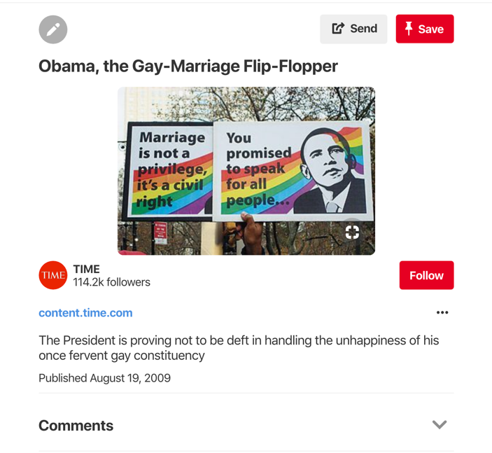

**Figure 3: Screen Shot of Pin Documenting Protest Posters featuring Obama Hope and Rainbows to Calling out Obama for his lack of Action in regard to Same-sex Marriage.**

The circulation of Obama Hope image, the archive reveals, only increased after Obama publicly declared his support for same-sex marriage and the overturning of DOMA. Not only did circulation increase, but the use of rainbows shifts from a shaming to celebratory tone. In one photograph, a protester holds an original Obama Hope poster while another holds that same poster remixed with the words "Obama Pride" and a rainbow Obama logo. Such rainbow effect was common in Obama Hope remixes. One remix that was printed onto buttons, for instance, features a rainbow-colored Obama with the word "Pride" while in other remixes, "Hope" was replaced with words such as "Pride" and "Evolved." For example, one image in the archive features the iconic image of Obama used in Fairey’s *Hope* Poster spray painted onto a fabric rainbow flag (much like the ones that are extremely prevalent at pride parades and celebrations) with the word pride appearing at the bottom (see Figure 4). Additionally, "Progress," one of the original words used in Fairey’s designs, was used in a rainbow-colored Obama Hope remix. From a vantage point of allyship, the celebratory nature of these images is clearly hailing Obama as an ally and resource for the LGB community. In a post on the site “The LGBT Update” featuring a rainbow rendition of the Obama Hope image, creator and editor INAPQ states “During his term as our nation’s elected commander and chief, President Barack Obama has clearly become the most outspoken U.S. President to support LGBT rights proudly. So by no surprise, President Obama stands strong once again with our Lesbian, Gay, Bi and Trans community, by officially declaring June as LGBT Pride Month" (INAPQ). Much like the rainbow stickers placed on business doors welcoming LGB patrons and straight individuals who wish to support socially progressive businesses, painting Obama with the iconic symbolism of the rainbow associates him both with the LGBT community as well as marks him as socially progressive and forward thinking.

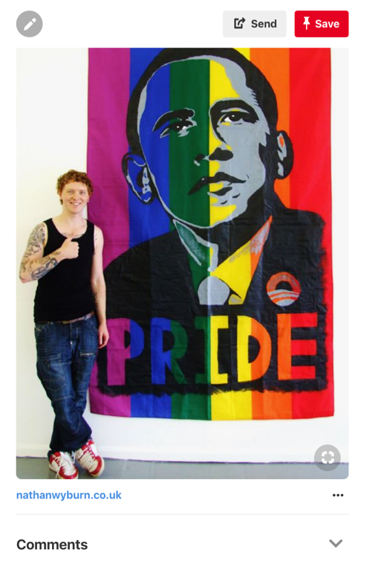

**Figure 4: Screen shot of Pin Containing a Photo of the Obama Hope Image Spray Painted on a Flag with the word “Pride.”**

It is important to consider the significance of the use of the rainbow to mark Obama as an ally to the community, rather than say images of Obama posing with actual gay and lesbian couples to signify Obama’s evolution of same-sex marriage. As Hairman and Lucaites claim, iconic images are important rhetorical vehicles that impact civic identities, attitudes, and actions, as they provide a means to both “read the public culture at any given period” and negotiate “basic attitudes toward policy” (381). In democratic public cultures such as the U.S., iconic images are able to do this work by appealing to citizen’s hope for freedom and equality—two values that are fundamental to civic notions of American citizenship. But iconic images can only do so if they do not also trigger other values that may counter those civic notions, a phenomenon that is especially important when it comes to the gay rights movement in which the depiction of same-sex couples can be risky rhetorical strategy for mainstream audiences. It has been found, for instance, that even those who don’t exhibit outwardly homophobic behaviors and attitudes become uncomfortable or may exhibit homophobic behaviors or attitudes when exposed to images depicting same sex romantic relationships as well as more explicit sexual acts (Bishop). This helps account for why advertisers often turn to abstract iconography rather than photographs of same sex couples. In their study examining gay-specific symbols in mainstream advertising, for instance, Oakenfull and Greenlee state “Use of implicit gay and lesbian imagery such as gay and lesbian iconography may allow marketers to effectively target the gay and lesbian consumers who will recognize the symbolism in the ad, while posing far less risk of offending heterosexual consumer” (423). When it comes to gay rights activism, this same principle applies. Thus, rather than showing Obama with actual depictions of same-sex relationships, which might trigger offense for some straight people, the rainbow is leaned on to trigger their ideals of equality and freedom (Hairman & Lucaites). In this way, the rainbow is able to both successfully speak to the LGB community and successfully appeal to the civic notions of Obama’s straight supporters.

**The Rhetorical Undercuts of Obama Pride**

While the rainbow colored “Evolution of Obama Pride” archive provides important contributions to queer rhetorical history, it is also important for digital visual historians to interrogate our own archival practices. We have an ethical obligation to acknowledge how our practice may contribute to oppressive ideologies and practices and potentially undercut our transformative ambitions. In order to explain this phenomenon, I'm offering the term *rhetorical undercut.* The term undercut refers to the ability to render unstable or undermine (Online Etymology Dictionary). Rhetorical undercutsrender archives and their contents unstable by acknowledging the double play present in archival collections. By acknowledging the rhetorical undercuts of archival work, we are able to both acknowledge the problematic nature of archival materials and practices as well as their productive and representational properties. The following paragraphs exemplify how rhetorical undercutsoperate within the “Evolution of Obama Pride” archive.

This Obama Hope archive could be read rhetorically in different ways, some positive for the queer community and some questionable. The early images are easily identifiable as rhetorics of resistance in regard to LGB individuals being denied citizenship and rights as humans. By using the Obama Hope image to call out Obama and his lack of active support, the creators and implementers of these artifacts ask to be treated equally by being included in the institution of marriage. However, in asking so, they uphold the heteronormative institution of marriage without critically examining the power dynamics and potentially problematic elements and history of marriage as an institution--a critique that was also forwarded about the Prop 8 movement on the whole: “Rather than move us towards a radical queering of citizenship, the No on 8 campaign reinvigorated a limited assimilationist identity politics celebrating conformity and alienating many in the very community it was purportedly fighting for” (Rohrer 115). The fight for and celebration of Obama’s recognition of same-sex marriage as a civil right in the production of Obama Hope remixes could thus been read as an example of Lisa Duggan’s new heteronormativity, “which does not contest dominant heteronormative assumptions and institutions but upholds and sustains them while promising the possibility of a demobilized gay constituency and privatized, depoliticized gay culture anchored in domesticity and consumption” (179). The images calling out Obama for his lack of support, as well as the later images that excitedly celebrate Obama’s “evolved” stance, encourage the embrace of same-sex marriage as the ultimate LGB battle and contribute to the assumption that all gay men and lesbian aspire to a nuclear family model of family building (Rohrer). In doing so, this archive could be read to uphold heteronormative ideologies in its efforts to build a queer rhetorical perspective into the visual artifacts of Obama's evolving stance toward same-sex marriage.

The “The Evolution of Obama Pride” archive also runs the risk of upholding the conflation between whiteness and gay and lesbian identities. In analyzing this archive, it becomes clear that while this archive makes visible those who supported and fought for same-sex marriage through the production of Obama Hope remixes in various protests, race is also erased. When the entire archive is viewed as a whole, there is a notable absence of Black bodies. Obama is the only Black person in all of the images, and he is often illustrated in the original red, white, and blue depiction that Fairey designed purposefully to erase Obama’s race to increase chances for identification among citizens of all races (Gries). Obama is also often colored with a rainbow effect. This coloring is clearly intended to signify Obama’s alliance with the LGBT community, but it perpetuates a post-racial representation of Obama that belies the complexities of being a black male in the United States today. In addition, a lack of black bodies is especially obvious in protest photos in which Obama Hope appears. In all the photos, white bodies are holding the signs calling out the Black president. This observation is only amplified by the affordances granted by Pinterest as an archival tool. When all of the images are placed next to each other with little or no written text, the presence of white bodies and absence of bodies of color is, in fact, glaring.

As an archive, the absence of bodies of color in association with Obama’s evolving stance on same-sex marriage risks upholding popular notions that the black community is more homophobic than its white counterparts. After the passage of Proposition 8, the black community was scapegoated for the bill’s passage in media reports. Initial reports claimed that 70 percent of black voters supported the passage of Prop 8, despite newer calculations placing the number closer to 58% (Coates). White, gay activists are guilty of vilifying the black religious community both during and after the passage of Prop 8 even though when church attendance was factored into the analysis of voting patterns during the 2008 elections, black voters did not differ from their white counterparts in regard to their support of same-sex marriage (Kaufman). The scapegoating of black voters in 2008 is yet another example of how blackness and LGB identities are often disentangled from each other. The “Evolution of Obama Pride” Pinterest board only contributes to such divorce in that the hyperpresence of white bodies calling out a black man for his lack of support for the LGB community erases the experiences of black and other people of color who also identify as part of the LGB community (Carbado).

Those of us using digital tools such as Pinterest to curate historical events thus must be aware of how the *rhetorical undercuts* present within our archives may reproduce moments of oppression or inequalities, despite our intentions to reveal or uncover forgotten histories. The emphasis on rainbow iconography and its associations with white (often cis-gendered gay men) members of the LGB community has ramifications that those of us curating these publicly available archives must contend with. One solution would be to broaden the parameters of the archive to explicitly seek out images and signs created by communities of color in response to Obama’s evolved stance on same-sex marriage.

**Conclusion**

Considering the critical readings of my archive above, when doing queer archival work in digital visual studies, researchers must be highly conscious of the archives they produce and the circulation of images and possible consequences that their archives might promote. Upon first glance, this archive indicates that the fight for same-sex marriage, as reflected in the evolution of the Obama Hope image’s design, is a productive narrative of progress. This archive can thus be interpreted as playing a small, but important role in documenting a part of U.S. history that often goes untold. By infiltrating these images and texts into the Pinterest universe, this queer archival practice centers LGBT concerns and makes them visible for public consideration. Both such rhetorical efforts are essential to queer rhetoric, in that, as Alexander and Rhodes argue, they help cultivate a broader sense of humanity and citizenship for typically underrepresented people. Scholars such as Rawson and Morris have argued for the importance of accessible of queer archives because they allow people to find themselves in history, as well as aid in the transmission of intergenerational knowledge to be passed down within queer communities. Additionally, as Rawson has argued, digital technologies presents ample opportunities for queer archives to not only be created but reach queer communities who may have trouble accessing materially based archives.

Despite the progress represented in the archive, as my readings of the archive suggests, not all progress is created equal, however, and the same can be said for Pinterest as an archival tool. Pinterest is an efficient and easy-to-use interface with the ability to collect, exhibit, curate, and share personal archives. As such, its potential for producing queer archives is technologically quite useful. However, as numerous authors have pointed out, Pinterest often upholds less savory things such as capitalism and traditional gender norms. Additionally, as I discovered in the engagement with my own archive, the visual emphasis enabled by Pinterest can highlight and reveal aspects of the LGB experience that are incredibly hetero and homonormative, as well as perpetuate a lack of intersectionality in relation to LGB identities. While Pinterest as an archival tool is useful for its ability to facilitate pattern recognition, it, like most academic tools of inquiry, does not preclude problematic archival practices. Despite many positive revelations, “The Evolution of Obama Pride” reveals how *rhetorical undercuts* often function in visual research processes to perpetuate already existing problematic representations.

While such *rhetorical undercuts* ought to be avoided, I am not arguing that Pinterest be dismissed as a productive digital archival tool. Instead, I am suggesting that we approach Pinterest and its affordances as an *impure platform*. As Phaedra Pezzullo argues with her conceptualization of impure politics, activist and resistance tactics can never be wholly pure, and, consequently, scholars must always consider how these tactics enable democratic social relationships. Pezzulo’s argument reinforces Peel and Harding's call for us to move beyond the "pro" and "con" arguments that make up so much of the discourse surrounding same-sex marriage in academic discourses and allow for same-sex marriage to be both assimilationist and transformative. By classifying Pinterest (and "The Evolution of Obama Pride") as impure, we acknowledge both its capitalistic, assimilationist and homonormative leanings and its ability to help accomplish more transformative work. We acknowledge, in other words, that despite the archive itself potentially upholding oppressive ideologies, Pinterest as a tool can help broaden audience access to LGBTQ history and break down some accessibility barriers present in more traditional archives, affordances that can have positive social impacts for this historically underrepresented community. For example, the suicide rate among gay youth dropped when marriage equality was passed (Raifman et al.). This is a tangible result of queer youth seeing themselves and their futures represented in the media. Pinterest can aid in allowing queer communities to access their history and see themselves as having a significant place in society and culture. If we as researchers can remain mindful of the impure nature of both our archives, as well as the tools we use to build them, then digital technologies such as Pinterest can aid us in not only collecting and curating visual data but also in the circulation of visual histories that are often not only overlooked but at risk of being forgotten.

**Works Cited**

Alexander, Jonathan and Jacqueline Rhodes.. “Queer Rhetoric and the Pleasures of the Archive.” *Enculturation,* 6 January 2012, <http://enculturation.net/queer-rhetoric-and-the-pleasures-of-the-archive>.

Almjeld, Jen. Collecting Girlhood: Pinterest Cyber Collections Archive Available Female Identities. *Girlhood Studies*, vol. 8, no. 3, 2015, pp. 6–22.

Belonksy, Andrew. “Obama: Prop 8 ‘Unnecessary,’ But Doesn’t Believe In Gay Marriage.” *Queerty,* 3 November 2008, <https://www.queerty.com/obama-prop-8-unnecessary-but-doesnt-believe-in-gay-marriage-20081103>.

Bishop, CJ. “Emotional Reactions of Heterosexual Men to Gay Imagery.” *Journal of Homosexuality*, vol.62, no. 1, 2014, pp. 51–66.

Carbado, Devon W. “Colorblind Intersectionality.” *Signs: Journal of Women in Culture and Society*, vol. 38, no. 4, 2013, pp. 811–845.

Caswell, Michelle, et al. “’To Suddenly Discover Yourself Existing’: Uncovering the Impact of Community Archives.” *The American Archivist*, vol. 79, no. 1, pp. 56–81.

CNN News, “Same-sex Marriage.” *CNN Politics*, 14 August 2008, http://www.cnn.com/ELECTION/2008/issues/issues.samesexmarriage.html.

Coates, Ta-Neishi. “Prop 8 and blaming the blacks.” *The Atlantic,* 7 January 2009, https://www.theatlantic.com/entertainment/archive/2009/01/prop-8-and-blaming-the-blacks/6548/.

Duggan, Lisa. “The New Heteronormativity: The Sexual Politics of Neoliberalism.” *Materializing Democracy: Toward a Revitalized Cultural Politics*, edited by Russ Castronova and Dana D. Nelson, Duke University Press, 2002, pp. 175–194.

Dwyer, Devin. “Obama’s “Evolving” Gay Marriage Stance. *ABC News,* 9 May 2012, http://abcnews.go.com/blogs/politics/2012/05/timeline-of-obamas-evolving-on-same-sex-marriage/.

Gries, Laurie E. *Still life with rhetoric: a new materialist approach for visual rhetorics*. Utah State University Press, 2015.

Gross, Michael Joseph. “Hope and History.” *The Advocate*, Sept. 2009, <https://www.advocate.com/society/military/2010/04/26/hope-and-history>.

Halberstam, Jack. *Female masculinity*. Duke Univ. Press, 2006.

Hariman, R., Lucaites, J.L., 2016. *The Public Image: Photography and Civic Spectatorship*. University of Chicago Press, Chicago.

Hariman, Robert and John Louis Lucaites. “Performing civic identity: The iconic photograph of the flag raising on Iwo Jima.” *Quarterly Journal of Speech,* vol. 88, no. 4, 2002, pp.363–392.

Jules, Bergis. “Confronting Our Failure of Care Around the Legacies of Marginalized People in the Archives.” *Medium,* 8 November 2016, <https://medium.com/on-archivy/confronting-our-failure-of-care-around-the-legacies-of-marginalized-people-in-the-archives-dc4180397280>.

Kaufman, David. “The Root: The Misjudged Black Vote On Gay Marriage.” *NPR,* 4 March 2011, https://www.npr.org/2011/03/04/134257733/the-root-the-misjudged-black-vote-on-gay-marriage.

Miller, Kenneth P. “The Democratic Coalition’s Religious Divide: Why California Voters Supported Obama but Not Same-sex Marriage.” *Revue francaise detudes americaines,* no. 119, 2009, pp. 46–62.

Mirchandani, Rajesh. “Obama: Letting down gay supporters?” *BBC News,* 10October 2009, <http://news.bbc.co.uk/2/hi/americas/8297500.stm>.

Morgan, Thad. “How Did the Rainbow Flag Become an LGBT Symbol?” *History*, 30 August 2018, <https://www.history.com/news/how-did-the-rainbow-flag-become-an-lgbt-symbol>.

Morris III, Charles E. “Archival Queer.” *Rhetoric & Public Affairs,* vol. 9, no. 1, 2006, pp. 145–151.

Morris III, Charles E. and K.J. Rawson. “Queer Archives/Archival Queers.” *Theorizing Histories of Rhetoric,* edited by Michelle Ballif, Southern Illinois University Press, 2013, pp.74-89.

Oakenfull, Gillian K. and Timothy B. Greenlee. “Queer eye for a gay guy: Using market-specific symbols in advertising to attract gay consumers without alienating the mainstream.” *Psychology & Marketing*, vol. 22, no. 5, 2005, pp. 421–439.

Ott, Brian L., Eric Aoki, and Greg Dickinson. “Ways of (Not) Seeing Guns: Presence and Absence at the Cody Firearms Museum.” *Communication and Critical/Cultural Studies*, vol. 8, no. 3, 2001, pp. 215–239.

Peel, Elizabeth and Rose Harding. “Divorcing Romance, Rights and Radicalism: Beyond Pro and Anti in the Lesbian and Gay Marriage Debate.” *Feminism & Psychology*, vol. 14, no. 4, 2004, pp. 588–599.

Pezzullo, Phaedra C. “Contextualizing Boycotts and Buycotts: The Impure Politics of Consumer-Based Advocacy in an Age of Global Ecological Crises.” *Communication and Critical/Cultural Studies*, vol. 8, no. 2, 2011, pp. 124–145.

Prelli, Lawrence J. *Rhetorics of Display*. Univ of South Carolina Press, 2006.

Queerty Staff. “Obama Pretends There’s No Such Thing As Prop 8 During California Visit.” *Queerty,* 28 May 2009,<https://www.queerty.com/obama-pretends-theres-no-such-thing-as-prop-8-during-california-visit-20090528>.

Rawson, K.J. “Accessing Transgender // Desiring Queer(er?) Archival Logics.” *Archivaria,* vol.68, 2009, pp. 123–140.

Raifman, Julia, et al. “Difference-in-Differences Analysis of the Association Between State Same-Sex Marriage Policies and Adolescent Suicide Attempts.” *JAMA Pediatrics,* vol. 171, no. 4, 2017, pp. 350–356.

Rohrer, Judy. “Black Presidents, Gay Marriages, and Hawaiian Sovereignty: Reimagining Citizenship in the Age of Obama.” *American Studies*, vol. 50, no. 3-4, 2009, pp. 107–130.

Shackleford, Lucy and Madonna Lebling. “Timeline of Obama’s gay marriage views.” *Washington Post,* 9 May 2012, <https://www.washingtonpost.com/politics/timeline-of-obamas-gay-marriage-views/2012/05/09/gIQArlQPEU_story.html>.

Stableford, Dylan. “Newsweek puts rejected Obama ‘first gay president’ covers online.” *Yahoo!,* 15 May 2012, https://www.yahoo.com/news/blogs/ticket/newsweek-puts-rejected-obama-gay-president-covers-online-185719568.html.

Steinmetz, Katy. “See Obama’s 20-Year Evolution on LGBT Rights.” *Time,* 10 April 2015, <http://time.com/3816952/obama-gay-lesbian-transgender-lgbt-rights/>.

Vetter, Matthew A. “Queer-the-tech: Genderfucking and Anti-Consumer Activism in Social Media.” *Harlot*, no. 11, <http://harlotofthearts.org/index.php/harlot/article/view/195/148>.

Wildermuth, John. “Obama Opposes Proposed Ban on Gay Marriage.” *San Francisco Gate*, 2 July 2008, <https://www.sfgate.com/news/article/Obama-opposes-proposed-ban-on-gay-marriage-3278328.php>.

Zarro, Michael et al. “Wedding Dresses and Wanted Criminals:  Pinterest.com as an Infrastructure for Repository Building.” *Proceedings of the Seventh International AAAI Conference on Weblogs and Social Media*, 2013, pp. 650–658.

1. Rawson argues the physical spaces that house archival material can pose at worse safety risks and at best a lack of comfort when queer individuals attempt to access materials house there. Rawson uses the example of bathroom access for transgender individuals as a barrier to archival access.